**PROCESS DIAGRAM**

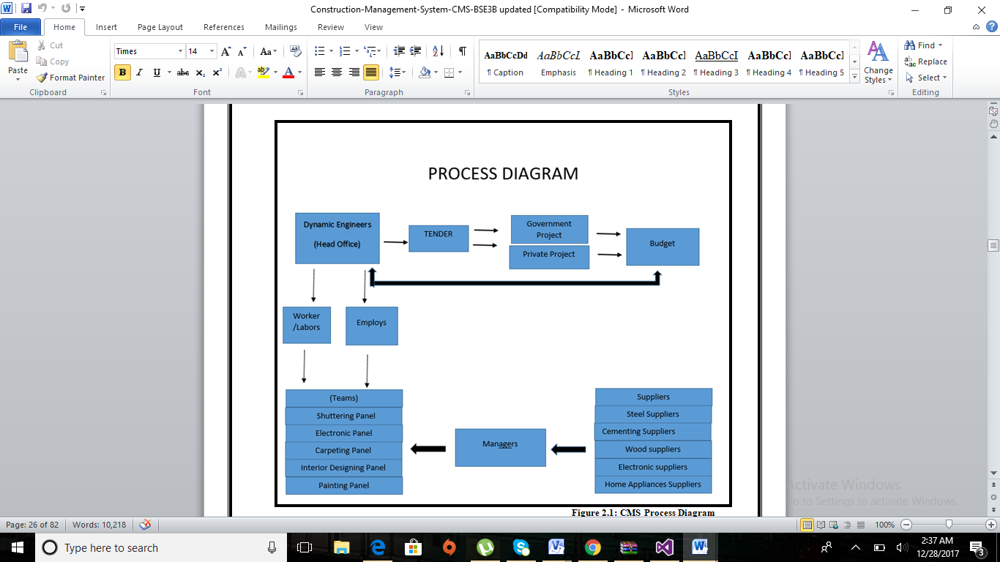

**WORKFLOW**

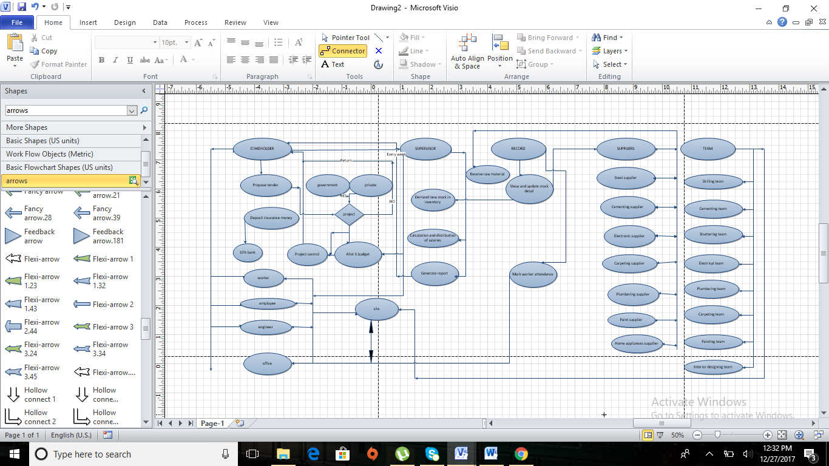

**CONTEXT DIAGRAM**

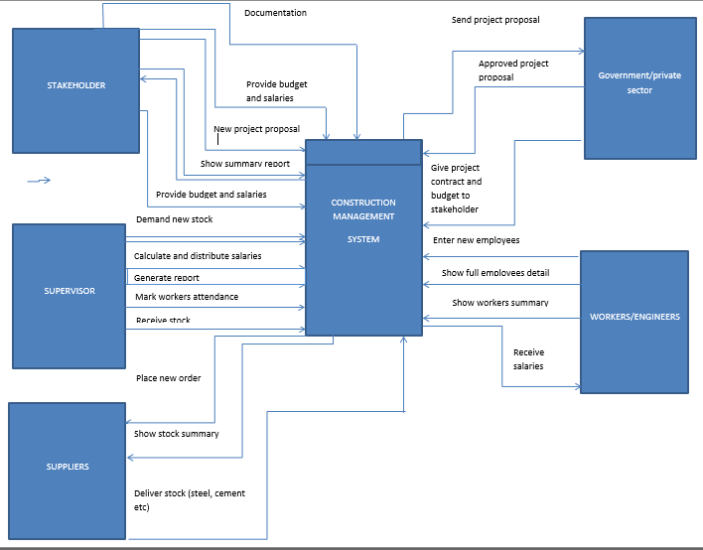

**ACTOR USE-CASE DIAGRAM**

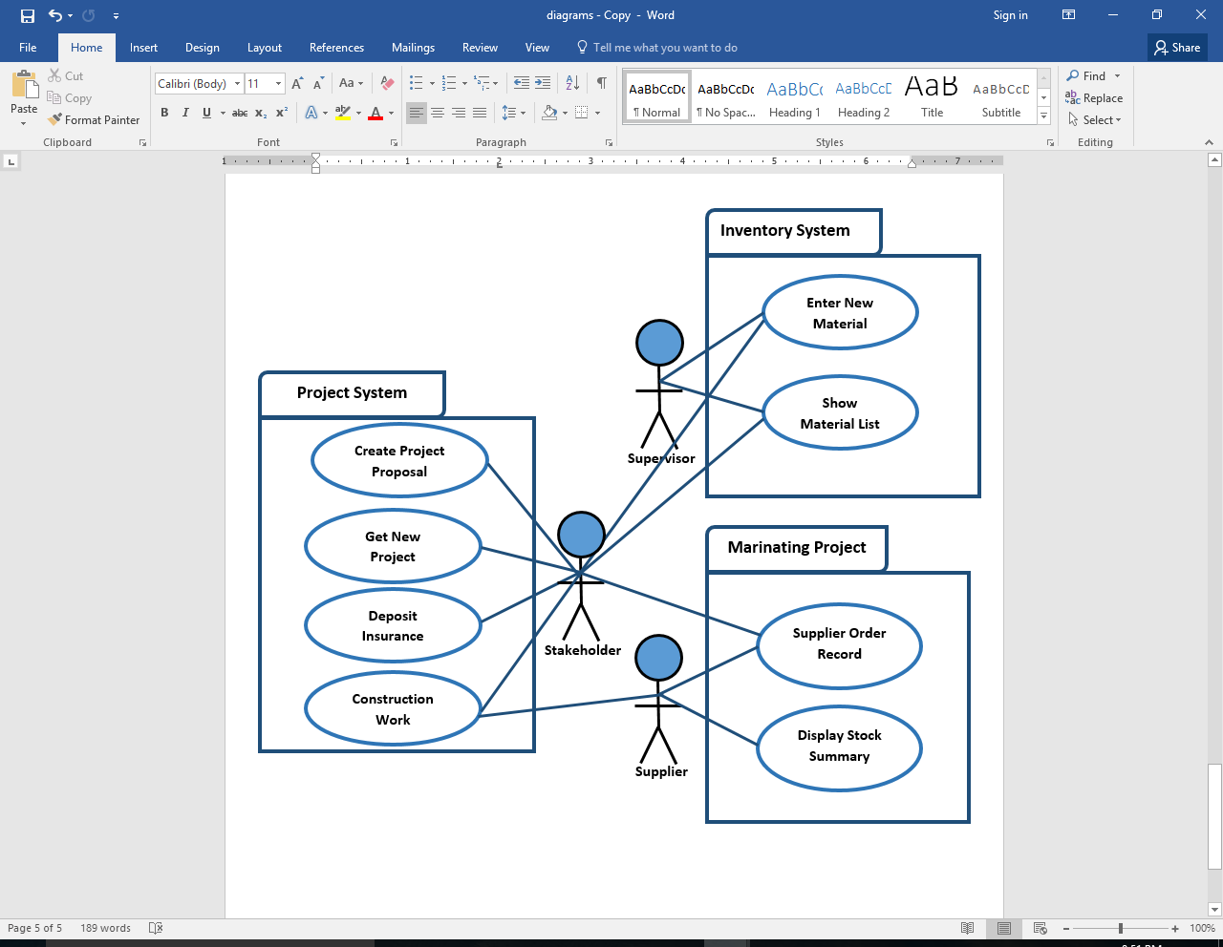

**OBJECT DIAGRAM**

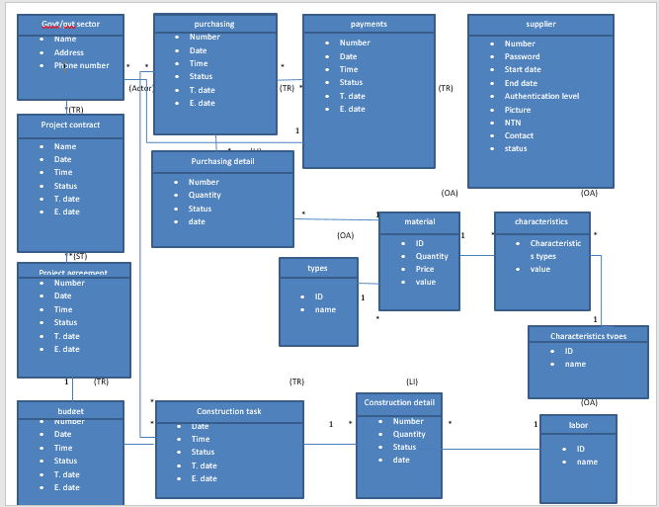

**CLASS DIAGRAM**

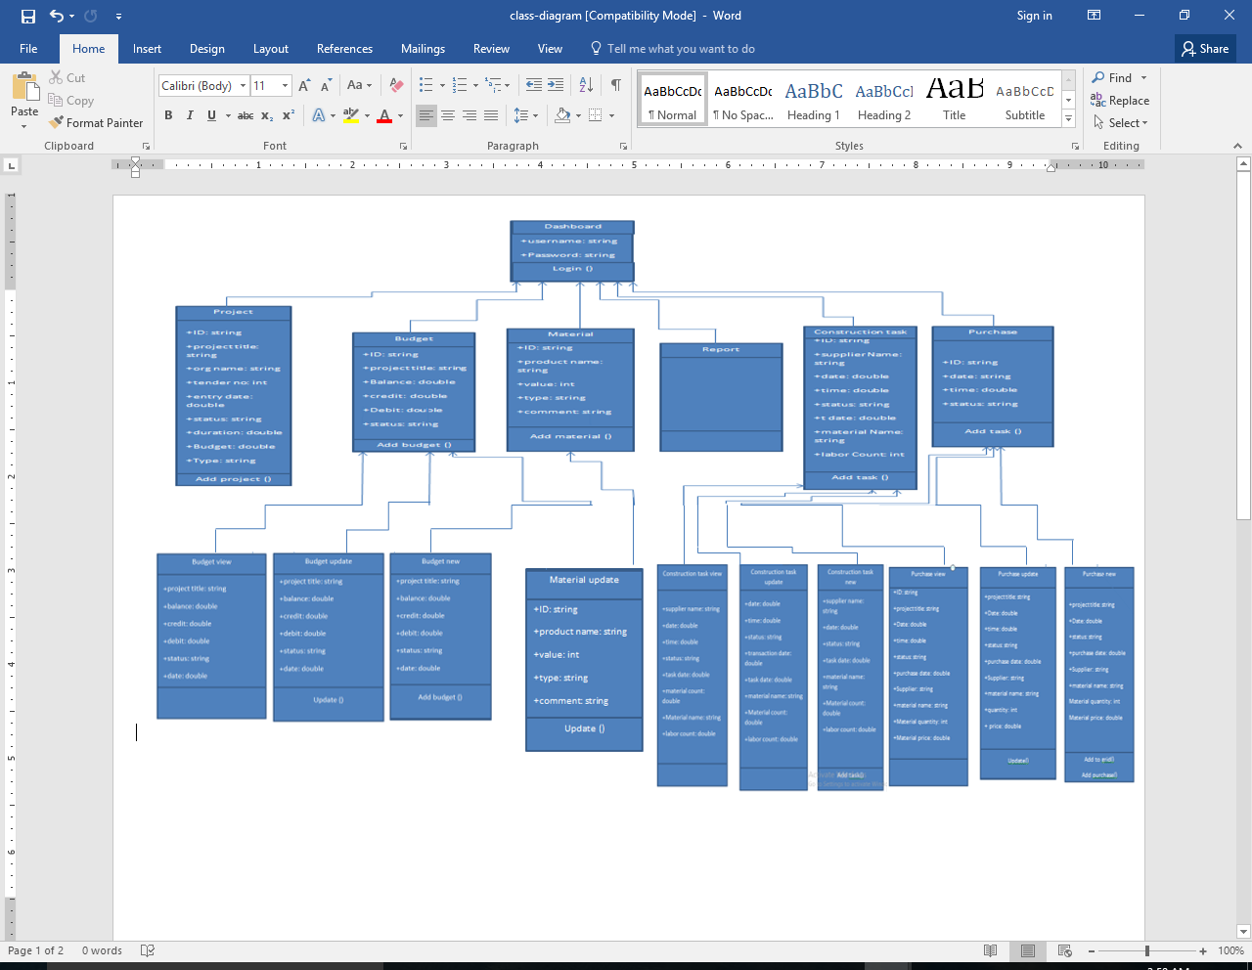

## DATABASE DIAGRAM

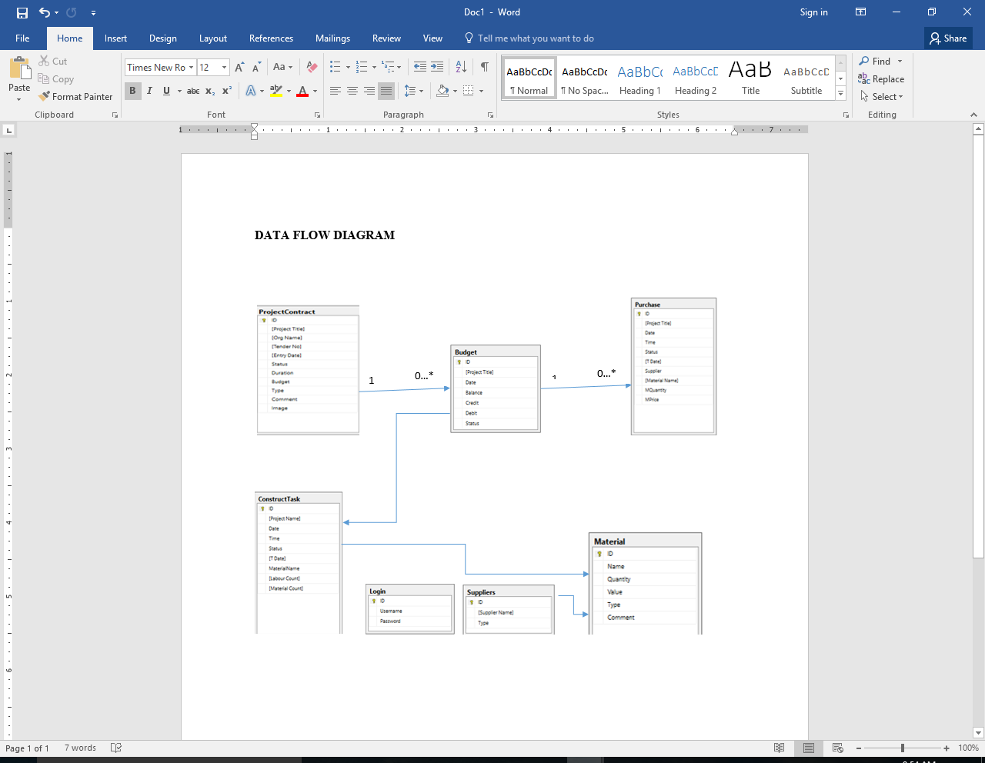

**COMPONENT AND DEPLOYMENT DIAGRAM**

